LANGUAGE TRANSLATION SYSTEM REPORT


BACHELOR OF TECHNOLOGY (B.TECH)
IN
COMPUTER SCIENCE AND ENGINEERING (CSE)

ACADEMIC YEAR: 2026-2027

SUBMITTED TO: | SUBMITTED BY:
Mr. Pawan Sharma | Team Name: J – Section C
Technical Trainer | Team Lead: Fatima Seemab
CSED | Total Members: 6
GROUP MEMBERS
MEMBER NAME | STUDENT ID
- FATIMA SEEMAB (LEADER) | BCS2023399
- SAKSHAM MISHRA | BCS2023387
- MAAZ | BCS2023217
- HAIDER HUSSAIN KHAN | BCS2023419
- VIPIN GANGWAR | BCS2023432
- PARTH SHRIVASTAV | BCS2023418

CERTIFICATE
This is to certify that the project report titled “Language Translation System” is the original work of Fatima Seemab along with team members of BTECH CSE Section C, during the academic year 2026-27, submitted in partial fulfilment of the requirements for the degree of Bachelor of Technology in Computer Science and Engineering.
This project has been carried out under the guidance of Mr. Pawan Sharma. The work has not been submitted elsewhere for any other degree or diploma.
The project demonstrates the application of transformer-based Natural Language Processing techniques for real-time English-to-Hindi translation.

Supervisor Signature

Mr. Pawan Sharma
Project Guide

ACKNOWLEDGEMENT
We would like to express our sincere gratitude to all those who have contributed to the successful completion of this project titled “Language Translation System.”
First and foremost, we extend our heartfelt thanks to our project guide, Mr. Pawan Sharma, for his valuable guidance, continuous support, and insightful suggestions throughout the development of this project. His mentorship and technical direction played a crucial role in shaping the overall structure and implementation of this work.
We would also like to express our gratitude to the Department of Computer Science and Engineering, Invertis University, for providing the necessary resources, infrastructure, and academic environment required to carry out this project effectively.
Our sincere thanks go to all the faculty members who directly or indirectly supported us with their knowledge, guidance, and encouragement during the course of this project. Their inputs helped us gain a deeper understanding of Natural Language Processing and its practical applications.
We are equally thankful to our family members and friends for their constant motivation, patience, and moral support, which encouraged us to complete this project successfully.
Finally, we acknowledge the collective efforts of all team members whose cooperation and participation contributed to the completion of this project. The experience gained through this work has been both enriching and insightful, enhancing our understanding of transformer-based models and real-world application development.
We hope that this project will serve as a useful contribution in the field of Natural Language Processing and help in addressing language barriers through efficient translation systems.
Team Members:
Group J
Fatima Seemab (Leader) and Team Members
B.Tech CSE (Academic Year 2026–2027)
ABSTRACT
The increasing need for communication across different languages has made language translation an essential tool in today’s globalized world. However, language barriers still pose significant challenges in areas such as education, information access, and real-time communication.
This project focuses on the design and development of an English-to-Hindi Language Translation System using transformer-based Natural Language Processing (NLP) techniques. The primary objective of the system is to provide efficient and real-time translation of English text into Hindi, reducing language barriers in communication and information access.
In many real-world scenarios, manual translation methods are time-consuming, costly, and not suitable for instant communication. Existing systems may also require significant computational resources or lack accessibility for general users.
To address these challenges, the system utilizes a pre-trained sequence-to-sequence transformer model (MarianMT) from the Hugging Face Transformers library. The input text is processed through tokenization, passed into the model for inference, and decoded into Hindi output. A web-based interface is developed using Flask along with HTML and CSS to provide a simple and user-friendly platform for interaction.
The system enables near real-time translation and allows users to input text and receive translated output instantly. It demonstrates reliable performance for general-purpose sentences and showcases the effectiveness of transformer models in handling contextual translation tasks.
This project highlights that pre-trained NLP models can be efficiently integrated into lightweight applications to provide accessible and practical translation solutions.
Keywords:
Language Translation, Natural Language Processing, Transformer Model, MarianMT, Hugging Face, Flask, Real-Time Translation

Table of Contents

INTRODUCTION 7
PROBLEM STATEMENT 8
OBJECTIVES 8
LITERATURE REVIEW 10
METHODOLOGY/SYSTEM DESIGN 11
Working Principle of the System 13
TOOLS AND TECHNOLOGIES 13
Python 13
Flask 13
Hugging Face Transformers 14
PyTorch 14
HTML and CSS 14
Hugging Face Spaces 14
IMPLEMENTATION 14
Implementation Flow 15
Code Snippet and Explanation 16
Algorithm for Translation Process 16
Key Components of the Implementation 17
RESULTS AND OUTPUT 18
Result Analysis 20
ADVANTAGES AND LIMITATIONS 21
Advantages: 21
Limitations: 21
FUTURE SCOPE 22
CONCLUSION 23
REFERENCES 23

INTRODUCTION
In today’s globalized world, communication across different languages has become increasingly important. With the rapid growth of the internet and digital platforms, people from diverse linguistic backgrounds interact frequently in areas such as education, business, and social communication. However, language barriers continue to limit effective information exchange and accessibility, especially for users who are not familiar with widely used languages like English.
Natural Language Processing (NLP) is a branch of artificial intelligence that focuses on enabling computers to understand, interpret, and generate human language. One of the key applications of NLP is machine translation, which involves automatically converting text from one language to another. Traditional translation methods, such as rule-based and statistical approaches, have limitations in capturing context and handling complex sentence structures.
Recent advancements in deep learning, particularly the introduction of transformer-based models, have significantly improved the performance of machine translation systems. Transformers use attention mechanisms to understand the relationships between words in a sentence, allowing them to capture context more effectively than earlier models. These models are capable of processing entire sentences at once and generating more reliable and coherent translations.
This project focuses on developing an English-to-Hindi language translation system using a pre-trained transformer model. Hindi is one of the most widely spoken languages in India, and providing translation support can enhance accessibility for a large population. The system leverages the Hugging Face Transformers library and integrates it into a web-based application using Flask, enabling users to input English text and receive translated Hindi output.
The proposed system aims to provide a simple, efficient, and user-friendly solution for real-time language translation. By utilizing pre-trained models, the project avoids the need for extensive training while still achieving reliable performance.

PROBLEM STATEMENT
Despite the increasing need for global communication, language barriers continue to be a major obstacle in the effective exchange of information. People who are not proficient in widely used languages, such as English, often face difficulties in accessing educational content, digital resources, and communication platforms. This creates a gap that limits inclusivity and equal access to information.
Traditional methods of translation, particularly manual translation, are time-consuming, expensive, and not suitable for real-time applications. In situations requiring instant communication, such as online interactions or live conversations, manual translation becomes impractical. Additionally, inconsistencies may arise due to variations in human interpretation.
Although several automated translation systems exist, many require significant computational resources or are not easily accessible for simple, everyday use. There is a need for a lightweight, efficient, and user-friendly system that can provide reliable translations in near real-time without requiring complex infrastructure.
Therefore, the problem addressed in this project is to develop a system that can automatically translate English text into Hindi efficiently and reliably. The system should minimize translation delay, maintain contextual accuracy, and provide an accessible interface for users with minimal technical knowledge.

OBJECTIVES
The primary objective of this project is to develop an efficient and user-friendly language translation system that converts English text into Hindi using modern Natural Language Processing (NLP) techniques. The system aims to demonstrate the practical application of transformer-based models for real-world translation tasks.
The specific objectives of this project are as follows:
• To design and implement a system capable of translating English text into Hindi with high reliability using a pre-trained transformer model.
• To enable near real-time translation with minimal response delay, ensuring a smooth user experience.
• To develop a simple and intuitive web-based interface that allows users to easily input text and view translated output.
• To integrate pre-trained NLP models in order to reduce the need for training from scratch and optimize computational efficiency.
• To deploy the system on a cloud-based platform, making it accessible for practical use and testing.
• To analyze the performance of the system in terms of translation quality and response time.

LITERATURE REVIEW
Language translation has been an important area of research in Natural Language Processing (NLP) for many years. Early approaches to machine translation were primarily rule-based systems, where linguistic rules and dictionaries were manually created to translate text from one language to another. Although these systems provided basic translations, they lacked flexibility and struggled with complex sentence structures and contextual meaning.
Later, statistical machine translation (SMT) methods were introduced, which relied on large bilingual datasets to generate translations based on probability. While SMT improved translation quality compared to rule-based approaches, it still faced limitations in capturing long-range dependencies and producing fluent sentences.
With advancements in deep learning, neural machine translation (NMT) emerged as a more effective approach. NMT models use neural networks to learn language patterns and generate translations with better fluency and context understanding. Recurrent Neural Networks (RNNs) and Long Short-Term Memory (LSTM) models were initially used for sequence-to-sequence translation tasks. However, these models process data sequentially, making them slower and less efficient for long sentences.
The introduction of transformer-based models marked a significant breakthrough in machine translation. Transformers use attention mechanisms to process entire sequences simultaneously, allowing them to capture contextual relationships more effectively. This leads to improved translation accuracy and faster computation compared to earlier models.
Modern translation systems, such as those provided by platforms like Google Translate and Hugging Face Transformers, utilize pre-trained transformer models to deliver high-quality translations across multiple languages. These models are trained on large-scale multilingual datasets and can be easily integrated into applications.
In this project, a pre-trained transformer model is used to implement an English-to-Hindi translation system. This approach leverages the strengths of modern NLP techniques while avoiding the need for extensive training, making it suitable for practical and efficient deployment.

METHODOLOGY/SYSTEM DESIGN
The methodology of the proposed system focuses on designing and implementing an efficient pipeline for translating English text into Hindi using a transformer-based model. The system integrates Natural Language Processing (NLP) techniques with a web-based interface to provide a seamless user experience.
The overall architecture of the system follows a sequence-to-sequence translation approach, where input text in English is processed and converted into corresponding Hindi output. The system consists of three main components: the user interface, the backend server, and the translation model.
The process begins with the user entering English text through a web-based interface developed using HTML and CSS. This interface is designed to be simple and intuitive, allowing users to input text easily and view the translated output without requiring technical knowledge.
Once the user submits the input, the request is sent to the backend server built using Flask. The Flask application handles incoming requests, processes the input text, and communicates with the translation model. This server acts as a bridge between the frontend and the machine learning model.
The input text is then passed to the tokenizer, which converts the text into a format that the model can understand. Tokenization involves breaking the input sentence into smaller units called tokens and encoding them into numerical representations.
After tokenization, the processed input is fed into the pre-trained transformer model (MarianMT). This model follows an encoder-decoder architecture. The encoder reads the input sequence and captures its contextual meaning, while the decoder generates the translated output sequence in Hindi. The model uses attention mechanisms to focus on relevant parts of the input while generating each word in the output.
Once the model generates the output tokens, they are passed through a decoding step to convert them back into readable Hindi text. The final translated output is then sent back to the frontend and displayed to the user.
The entire process is optimized to provide near real-time translation, typically generating results within a few seconds. By using a pre-trained model from the Hugging Face Transformers library, the system avoids the need for extensive training while still achieving reliable performance.
The workflow of the system can be summarized as follows:
Input Text → Tokenization → Model Processing → Output Generation → Display Result
This modular design ensures that each component of the system functions efficiently and can be easily extended in the future to support additional features such as multi-language translation or voice-based input.
Figure 1: System Architecture of English-to-Hindi Translation System
DISPLAY UI
TOKENIZER
USER INPUT (ENGLISH)
OUTPUT (HINDI)
TRANFORMER MODEL
(ENCODER -> DECODER)

Working Principle of the System
The working principle of the system is based on the concept of sequence-to-sequence translation using transformer models. The system takes an input sentence in English and processes it through multiple stages to generate the corresponding Hindi translation.
Initially, the input text is converted into tokens using a tokenizer. These tokens are numerical representations of words and are suitable for processing by the model. The transformer model then analyzes these tokens using its encoder, which captures the contextual relationships between words in the sentence.
The decoder component of the model generates the translated output step by step, using attention mechanisms to focus on relevant parts of the input. This ensures that the translation maintains contextual meaning rather than just word-to-word conversion.
Finally, the generated tokens are converted back into readable Hindi text and displayed to the user. This process enables efficient and context-aware translation within a short time.

TOOLS AND TECHNOLOGIES
The development of the English-to-Hindi translation system involves the use of several tools and technologies that work together to enable efficient processing, model inference, and user interaction. Each component plays a specific role in the overall functioning of the system.
Python
Python is used as the primary programming language for implementing the backend logic of the system. It provides extensive support for machine learning and Natural Language Processing through various libraries, making it suitable for developing AI-based applications.
Flask
Flask is a lightweight web framework used to build the backend server. It handles user requests, processes input data, and communicates with the translation model. Flask acts as a bridge between the frontend interface and the machine learning components.
Hugging Face Transformers
The Hugging Face Transformers library provides access to pre-trained state-of-the-art NLP models. In this project, it is used to load and utilize a pre-trained sequence-to-sequence model (MarianMT) for performing English-to-Hindi translation efficiently.
PyTorch
PyTorch is the underlying deep learning framework used by the Transformers library for executing the model. It manages tensor computations and model operations required during the translation process.
HTML and CSS
HTML and CSS are used to design the frontend interface of the application. They provide a simple and user-friendly layout for entering input text and displaying the translated output.
Hugging Face Spaces
Hugging Face Spaces is used as a cloud deployment platform for hosting the application. It allows the system to be accessed online, making it easier to test and demonstrate the project in a real-world environment.

IMPLEMENTATION
The implementation of the English-to-Hindi translation system involves integrating a pre-trained transformer model with a web-based interface to perform real-time translation. The system is developed using Python, Flask, and the Hugging Face Transformers library.
The implementation begins with setting up the Flask application, which acts as the backend server. Flask is responsible for handling user requests, processing input data, and returning the translated output to the frontend.
A pre-trained translation model (MarianMT) is loaded using the Hugging Face Transformers library. Along with the model, a corresponding tokenizer is also initialized. The tokenizer is used to convert input text into a format suitable for the model.
When a user enters English text in the input field and submits it, the data is sent to the Flask server through an HTTP request. The server receives the input and passes it to a translation function.
Inside the translation function, the following steps are performed:
- First, the input text is tokenized using the tokenizer. This process converts the sentence into numerical tokens that can be understood by the model.
- Next, the tokenized input is passed to the model for inference. The model processes the input using its encoder-decoder architecture and generates output tokens corresponding to the Hindi translation.
- After the model generates the output tokens, they are decoded back into human-readable Hindi text using the tokenizer.
- Finally, the translated text is sent back to the frontend and displayed to the user through the web interface.
The overall implementation flow can be summarized as:
User Input → Flask Server → Tokenization → Model Inference → Decoding → Output Display
The system is designed to provide near real-time translation, with results typically generated within a few seconds. By leveraging a pre-trained model, the implementation avoids the need for extensive training while maintaining reliable translation performance.
This modular implementation allows easy extension of the system, such as adding support for additional languages or integrating voice-based input and output features in the future.

Implementation Flow
The overall implementation follows a structured pipeline to ensure smooth processing of input text and generation of translated output. Initially, the user enters English text through the web interface, which is sent to the Flask backend server. The server processes the input and forwards it to the tokenizer.
The tokenizer converts the input text into numerical tokens that can be understood by the model. These tokens are then passed to the transformer model, which performs translation using its encoder-decoder mechanism. Finally, the generated tokens are decoded into Hindi text and displayed to the user through the interface.
Figure 2: Code Snippet for Translation Function
def translate_text(text):
inputs = tokenizer(text, return_tensors="pt", padding=True)
translated = model.generate(**inputs)
output = tokenizer.decode(translated[0], skip_special_tokens=True)
return output

Code Snippet and Explanation
The following code snippet represents the core translation function used in the system. It demonstrates how input text is processed and converted into translated output using the transformer model.
- Tokenization: The input text is first processed using a tokenizer, which converts it into numerical tokens that can be understood by the model. This step ensures that the text is in a suitable format for model processing.
- Model Generation: The tokenized input is passed to the transformer model, which generates the translated sequence using its encoder-decoder architecture. The model uses learned contextual relationships to produce reliable translations.
- Decoding: The generated tokens are decoded back into readable Hindi text. This final output is then returned and displayed to the user through the web interface.

Algorithm for Translation Process
Step 1: Accept input text from user
Step 2: Convert input into tokens using tokenizer
Step 3: Pass tokens to transformer model
Step 4: Generate translated output tokens
Step 5: Decode tokens into Hindi text
Step 6: Display result on interface

Key Components of the Implementation
The system consists of multiple components that work together to perform translation.
- The frontend interface allows users to input text and view results.
- The Flask backend handles requests and manages communication with the model.
- The transformer model performs the core translation task by processing input tokens and generating output sequences.
These components are integrated to ensure efficient and user-friendly operation of the system.

RESULTS AND OUTPUT
The developed system was tested with various English input sentences to evaluate its translation performance and usability. The system successfully generates Hindi translations in near real-time, demonstrating its practical applicability.
The user interface allows users to enter English text and receive the translated Hindi output instantly. The results are displayed clearly, making the system easy to use for non-technical users.
Several sample inputs and their corresponding outputs are shown below:
Example 1:
Input: "Hello, how are you?"
Output: "नमस्ते, आप कैसे हैं?"
Example 2:
Input: "This is a language translation system."
Output: "यह एक भाषा अनुवाद प्रणाली है।"
Example 3:
Input: "Artificial Intelligence is transforming the world."
Output: "कृत्रिम बुद्धिमत्ता दुनिया को बदल रही है।"
The system demonstrates reliable translation performance for common sentences and general-purpose text. The response time is typically within a few seconds, enabling near real-time interaction.
Figure 3: Deployed Application on HuggingFace Showing Input and Output 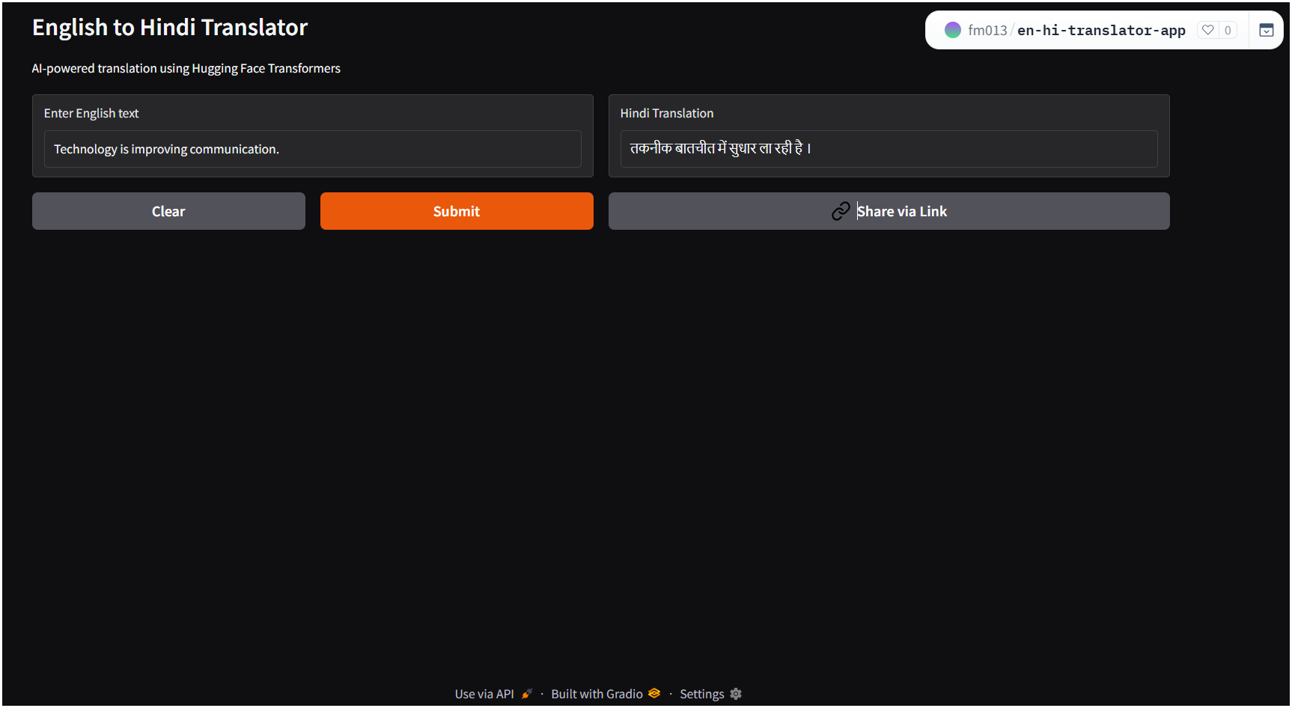
Figure 4: Input Interface Screenshot
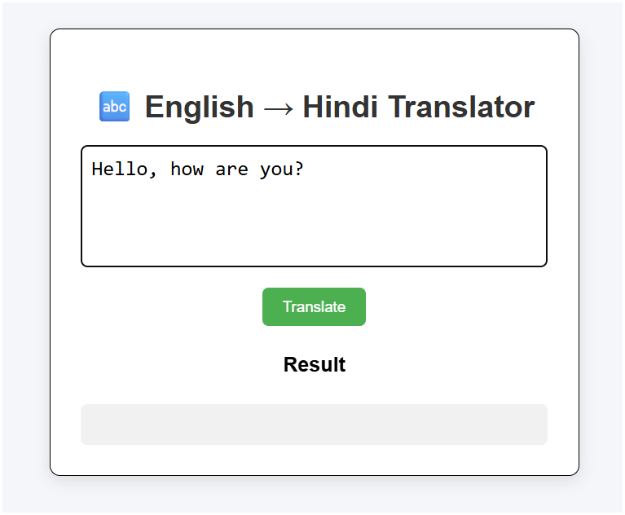
Figure 5: Translation Output Screenshot
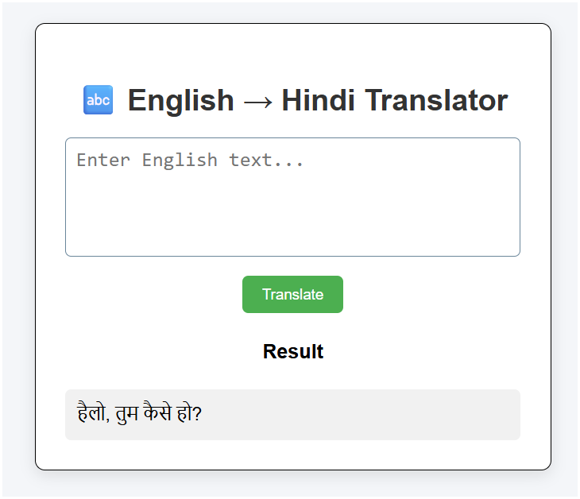

Result Analysis
The system performs effectively for general-purpose sentences and produces understandable Hindi translations. It is observed that the model handles simple and moderately complex sentences well, maintaining the overall meaning of the input.
However, for highly complex or ambiguous sentences, minor variations may occur in the output. This is expected, as the model relies on learned patterns and contextual relationships rather than explicit grammatical rules.
Overall, the system demonstrates reliable performance for practical usage scenarios and validates the effectiveness of transformer-based models in language translation tasks.

ADVANTAGES AND LIMITATIONS

Advantages:
- The proposed English-to-Hindi translation system offers several benefits in terms of usability and performance. One of the key advantages is its ability to provide near real-time translation, allowing users to quickly obtain translated output. This makes the system suitable for practical applications where fast communication is required.
- Another advantage is the use of a pre-trained transformer model, which eliminates the need for training a model from scratch. This significantly reduces computational cost and development time while still providing reliable translation results.
- The system also features a simple and user-friendly interface, making it accessible to users with minimal technical knowledge. The web-based design allows easy interaction without requiring installation of complex software.
- Additionally, the system is scalable and can be extended to support multiple languages or additional features such as speech-based input and output.

Limitations:
- Despite its advantages, the system has certain limitations. One of the main limitations is that it currently supports only a single language pair, i.e., English to Hindi. This restricts its usability for multilingual translation tasks.
- The system relies on a pre-trained model, which means that it may not always produce perfectly accurate translations, especially for complex or ambiguous sentences. Minor variations in output may occur depending on sentence structure and context.
- Another limitation is that the system requires an internet connection when deployed online, which may affect accessibility in offline environments.
- Furthermore, the model may not handle highly domain-specific or technical language effectively, as it is trained on general-purpose data.

FUTURE SCOPE
The current system demonstrates the practical implementation of an English-to-Hindi translation model; however, there are several opportunities for further enhancement and expansion.
One of the major improvements can be the addition of multi-language support. The system can be extended to translate between multiple Indian and international languages, making it more versatile and useful for a wider audience.
Another important enhancement is the integration of speech-to-text functionality. This would allow users to provide input through voice, making the system more accessible and convenient, especially for users who prefer spoken interaction.
Similarly, text-to-speech functionality can be incorporated to convert the translated Hindi text into audio output. This would create a complete voice-based translation system, improving usability for visually impaired users and enhancing user experience.
The system can also be developed into a mobile application, enabling users to access translation services on smartphones. A cross-platform mobile app would increase portability and real-world usability.
Further improvements can include optimizing the model for faster performance and reduced resource usage. Techniques such as model compression or lightweight architectures can be explored to enable deployment on low-resource devices.
Overall, these enhancements can significantly improve the functionality, accessibility, and scalability of the system in future implementations.

CONCLUSION
This project presents the development of an English-to-Hindi language translation system using transformer-based Natural Language Processing techniques. The system demonstrates how pre-trained models can be effectively integrated into a web-based application to perform real-time translation tasks.
The implemented solution successfully translates English text into Hindi with reliable performance and minimal response time. The use of a pre-trained transformer model eliminates the need for extensive training while still delivering context-aware translations.
The system provides a simple and user-friendly interface, making it accessible to users with varying levels of technical expertise. The integration of frontend and backend components ensures smooth interaction and efficient processing of input data.
Overall, the project highlights the practical application of modern NLP techniques in addressing real-world problems such as language barriers. It also provides a foundation for further enhancements, including multi-language support and voice-based interaction.

REFERENCES
- Hugging Face Transformers Documentation
https://huggingface.co/docs/transformers
- MarianMT Model (Helsinki-NLP)
https://huggingface.co/Helsinki-NLP/opus-mt-en-hi
- Flask Documentation
https://flask.palletsprojects.com/
- PyTorch Documentation
https://pytorch.org/docs/
- Jurafsky, D., & Martin, J. H. (2021). Speech and Language Processing.

